* Install Google Earth
* Open Google Earth and in the Layers panel ensure that the items shown below are selected.

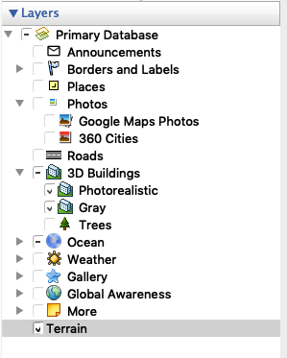

* Open the attached .kml validation file in Google Earth. You should see a section of the map populated with grey 3D buildings.
* Compare the grey buildings with the Google versions. Check for errors, e.g.
* Are there grey buildings that do not exist in the Google version and vice versa.
* Are there any grey buildings or parts of grey buildings whose height is very different from their counterparts height in Google?
* Are there any grey buildings that seem to have the wrong shape?
* Are there grey buildings that seem to be in the wrong place?
* Please note that the grey building heights are not expected to be an exact match for those in Google. I am interested in finding those buildings that differ fairly substantially from Google’s. Which differences would cause a noticeable problem in the context of a 3.5mx2m physical model. Please pay particular attention to landmark buildings. Use your own judgment but, for example, these differences are OK and should not be logged as an issue:

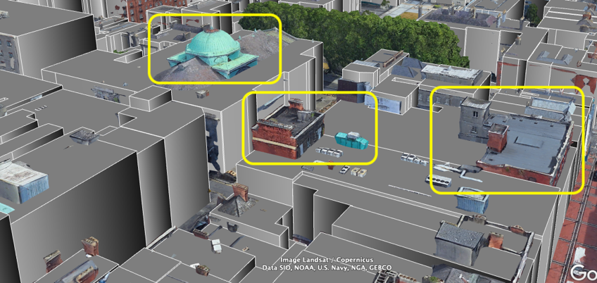

* These are a problem and should be logged:
* 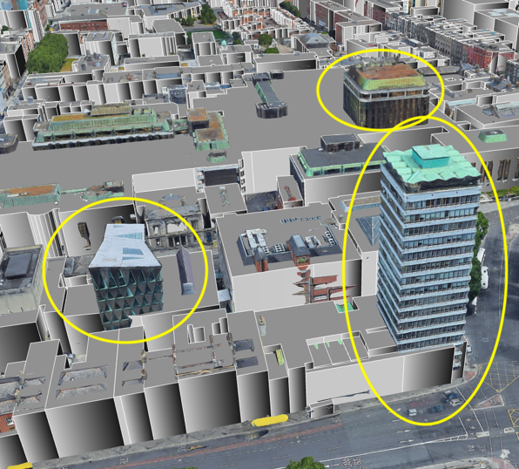
* To help making comparisons you can
* Toggle all the the grey buildings on/off by clicking beside the Validation Tile name in the Places panel on the left.

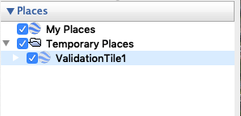

* Toggle individual buildings on/off by clicking on the building to reveal it's ID in the KML folder in the Places panel (click on disclosure triangle at the Validation Tile entry), then clicking next to that ID:

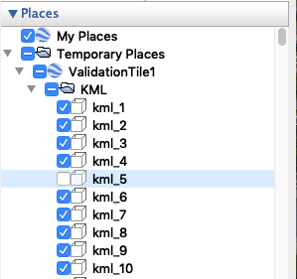

* Whenever you find an issue, add a placemark at the location of the issue.

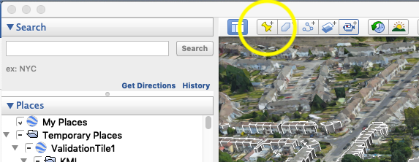

There’s no need to name the placemark. When you have identified all your issues, you should have a list of Untitled Placemarks:

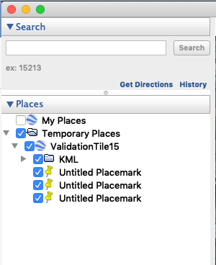

Select all of the Placemarks and drag them up so they sit under the My Places entry:

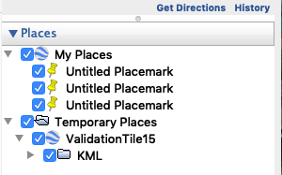

Right click on My Places and choose ‘save Place as…’ The resulting file should contain all of your Placemarks. Please email these to [Mark.Linnane@mu.ie](mailto:Mark.Linnane@mu.ie)

Thanks for your help!